**DATA MANAGEMENT PROJECT REPORT**

(Project Semester: August-December 2021)



**IPL DATA ANALYSIS**

# Submitted by

**Kesana Bhanu ManiKanta**

**11904233**

Program and Section: B.Tech (CSE), KM010

Course Code: INT217

Under the Guidance of

**Harneet Kaur - 19371**

**The discipline of CSE/IT**

**Lovely School of Computer Science & Engineering**

**Lovely Professional University, Phagwara**

# CERTIFICATE

This is to certify that KESANA BHANU MANIKANTA bearing Registration no. 11904233 has completed the INT217 project titled, **“IPL DATA ANALYSIS”** under my guidance and supervision. To the best of my knowledge, the present work is the result of his original development, effort, and study.

**Harneet Kaur**

**School of Computer Science & Engineering**

**Lovely Professional University Phagwara, Punjab.**

Date:

**DECLARATION**

I, Kesana Bhanu ManiKanta, student of B.Tech CSE under CSE/IT Discipline at, Lovely Professional University, Punjab, hereby declare that all the information furnished in this project report is based on my intensive work and is genuine.

Date:

Registration No.: 11904233 Kesana Bhanu ManiKanta

**ACKNOWLEDGEMENT**

I would like to express my special thanks of gratitude to my teacher Mrs. Harneet Kaur who gave me the golden opportunity to do this wonderful project of analysis of the data of a superstore namely “IPL DATA ANALYSIS” which also helped me in doing a lot of research and I came to know about so many new things. I am thankful to them.Secondly, I would also like to thank my parents and friends who helped me a lot in finalizing this project within the limited time frame.

**TABLE OF CONTENT**

1. Introduction
2. Scope of the Analysis
3. Source of the dataset
4. ETL process
5. Analysis of dataset (for each analysis)
   1. Introduction
   2. General Description
   3. Specific Requirements, functions, and formulas
   4. Analysis results
   5. Visualization
6. List of Analysis with results
7. References
8. Bibliography

## **INTRODUCTION**

**Data Analysis** is a process of inspecting, cleansing, transforming, and modeling data to discover useful information, informing conclusions, and supporting decision-making. Data analysis has multiple facets and approaches, encompassing diverse techniques under a variety of names while being used in different business, science, and social science domains.

The analytics team of INDIAN PREMIER LEAGUE (IPL) association and BCCI association anywhere in the world would love to check ours through data analysis of every match leading to well-organized and fruitful information. My analysis contains data on host teams, all stadiums, the most supported team, and the most successful teams.

The Indian Premier League (IPL), is a Professional 20-20 cricket league in India contested during April and May of every year by teams representing Indian cities and some states. The league was founded by the Board of control of cricket India (BCCI) in 2008 and is regarded as the brainchild of Lalit Modi, the founder and former commissioner of the league. IPL has an exclusive window in ICC Future Tours Programs.

The IPL is the most-attended cricket league in the world and in 2014 ranked sixth by average attendance among all sports leagues. In 2010, the IPL became the first sporting event in the world to be broadcast live on youtube. The brand value of IPL in 2017 was US$6.3 billion, according to Duff and help. According to BCCI, the 2015 IPL season contributed ₹11.5 billion (US$182 million) to the GDP of the Indian economy.

There have been eleven seasons of the IPL tournament. The current IPL title holders are the CSK, who won the 2018 season. The most successful franchises in the tournament are the CSK and MI with 3 tournament wins each.

**Prize Money:**

The 2015 season of the IPL offered total prize money of ₹40 crores (US$5.6 million), with the winning team netting ₹15 crores (US$2.1 million). The first and second runners-up received 10 and 7.5 crores, respectively, with the fourth-placed team also winning 7.5 crores.

The others teams are not awarded any prize money. The IPL rules mandate that half of the prize money must be distributed among the players.

**Rules:**

**IPL** games utilize television timeouts and hence there is no time limit in which teams must complete their innings. However, a penalty may be imposed if the umpires find teams misusing this privilege. Each team is given a two-and-a-half-minute "strategic timeout" during each innings; one must be taken by the bowling team between the ends of the 6th and 9th overs and one by the batting team between the ends of the 13th and 16th overs.

**Insights of data:**

**INDIAN PREMIER LEAGUE ANALYSIS** contains the following data fields: -

* Season year– The year on which the following match is held.
* Date – Contains date on which the match is held.
* Venu-Venu in which match is held.
* City – City in which match is held.
* Toss-Winner –Who is the toss winner.
* Toss Decision –What team decided after winning the toss.
* Match-Winner – Who won the match.
* Win by run – This shows by how many runs does the team wins.
* Win by Wicket – This shows how many wickets the team wins.
* Man of the match – Who won the player of the match.
* ID– This column shows the match number.
* Win margin- By how many runs a team won the match

# SCOPE OF ANALYSIS

This project on Indian Premiere League Statistics of India provides the overall Statistics details of the matches of IPL and teams progress in various aspects from the year 2008 to 2015.

**Objectives of this project:**

* To good hand on excel.
* To use the different features and get friendly with excel.
* To learn the ETL process in the Tableau Prep.
* How to link one sheet to another and traverse between different sheets.
* How to use a pivot table and pivot chart.
* Learn to make dashboards in excel.
* To make a different types of graphs in excel.
* To learn how to fetch data from another source to excel in different formats.

This project aims to answer the above objectives in the form of visualization by creating a dashboard to convey the answers effectively and efficiently.

## **SOURCE OF DATASET**

The data is being taken from the Kaggle. Kaggle is an AirBnB for Data Scientists – this is where they spend their nights and weekends. It’s a crowd-sourced platform to attract, nurture, train, and challenge data scientists from all around the world to solve data science, machine learning, and predictive analytics problems. It has over 536,000 active members from 194 countries and it receives close to 150,000 submissions per month. Starting from Melbourne, Australia Kaggle moved to Silicon Valley in 2011, raised some 11 million dollars from the likes of Hal Varian (Chief Economist at Google), Max Levchin (Paypal), Index, and Khosla Ventures, and then ultimately been acquired by Google in March of 2017. Kaggle is the number one stop for data science enthusiasts all around the world who compete for prizes and boost their Kaggle rankings. There are only 94 Kaggle Grandmasters in the world to this date.

# ETL PROCESS

In computing, extract, transform, load (ETL) is a process in database usage to prepare data for analysis, especially in data warehousing. Data extraction involves extracting data from homogeneous or heterogeneous sources, while data transformation processes data by transforming them into a proper storage format/structure for the purposes of querying and analysis; finally, data loading describes the insertion of data into the final target database such as an operational data store, a data mart, or a data warehouse. A properly designed ETL system extracts data from the source systems, enforces data quality and consistency standards, conforms data so that separate sources can be used together, and finally delivers data in a presentation-ready format so that application developers can build applications and end users can make decisions.

Precisely, ETL is defined as a process that extracts the data from different RDBMS source systems, then transforms the data (like applying calculations, concatenations, etc.) and finally loads the data into the Data Warehouse system. ETL stands for Extract, Transform and Load.

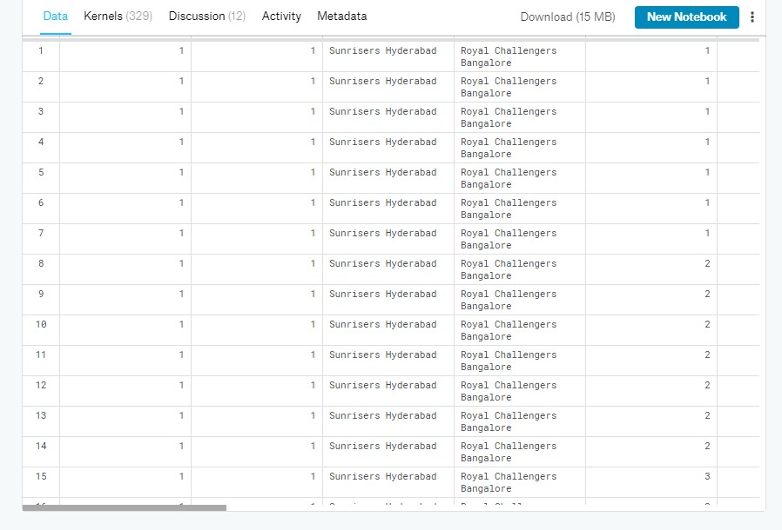Before ETL, the dataset looked like this. **This data is taken from Kaggle.**

Through the process of ETL, we are going to clean the dataset and bring all the entities to their proper data format.

**Step 1: Removing the blank cells from the dataset.**

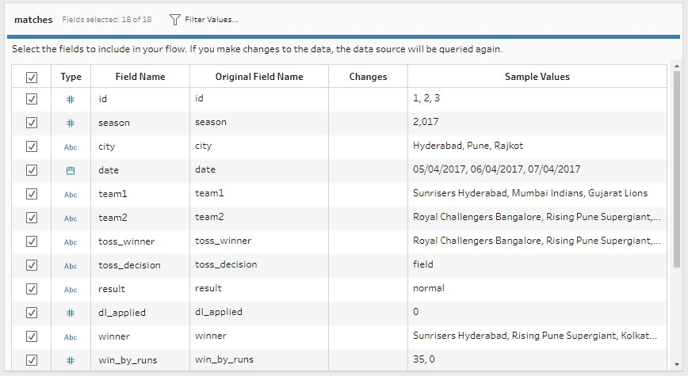For this, select the whole dataset. Go to Find and Select in the Home tab of excel. Select Go to Special from the drop-down menu and then tick the blank option. All the blank cells will be selected. Then go to Delete option in the home tab again and select Delete Rows from the drop-down menu. This will remove any rows with blank cells.

**Step 2: Removing columns which are not properly defined or not crucial to our analysis.**

For this we will columns which are redundant like the column with just the index numbers. For this we will select that particular column and then go to delete option in the home tag and then select Delete Columns from the drop-down menu.

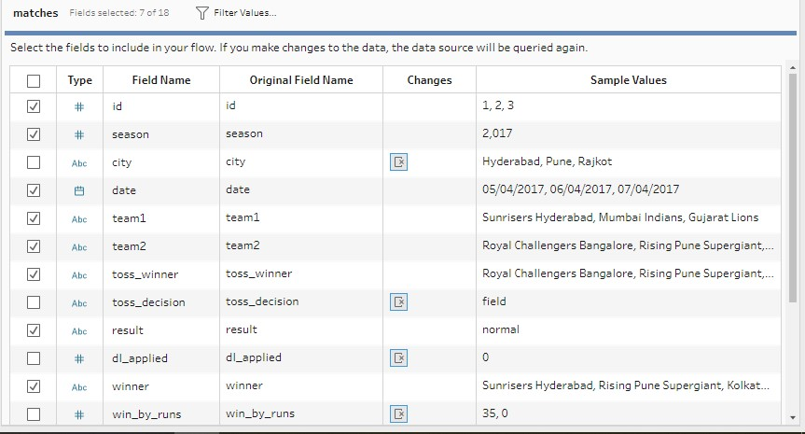

**Step 3: Giving proper and appropriate column names.**

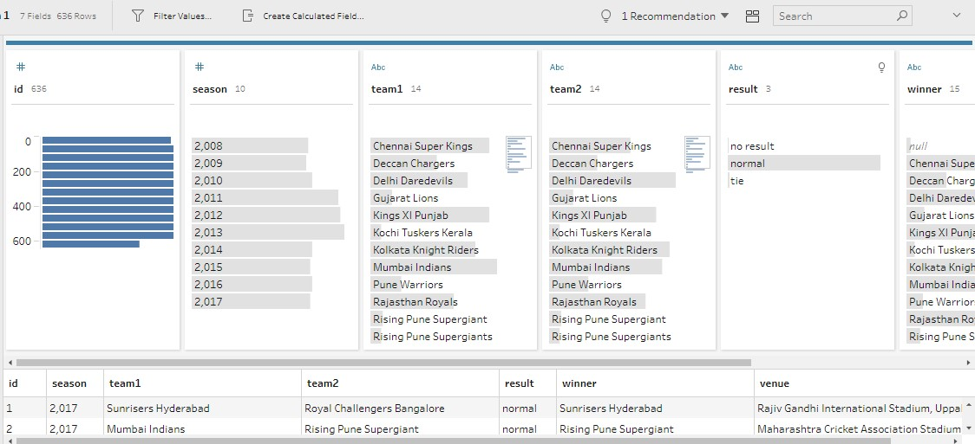The dataset does not have proper columns so our next step would be to giver proper column names to the columns wherever required.

# ANALYSIS OF DATASET

**1. Total matches won by team1 and team2**

**Description:**

In this objective we will be finding the total number of wins by each team in team1 and team2.For this we will be using the total number of wins by each team in the form of team1 and team2.

**Specific function and requirements**

We have to create a pivot table to determine the difference in wins by team1 and team2 and then visualize it on pie chart(team1) and graph(team2).

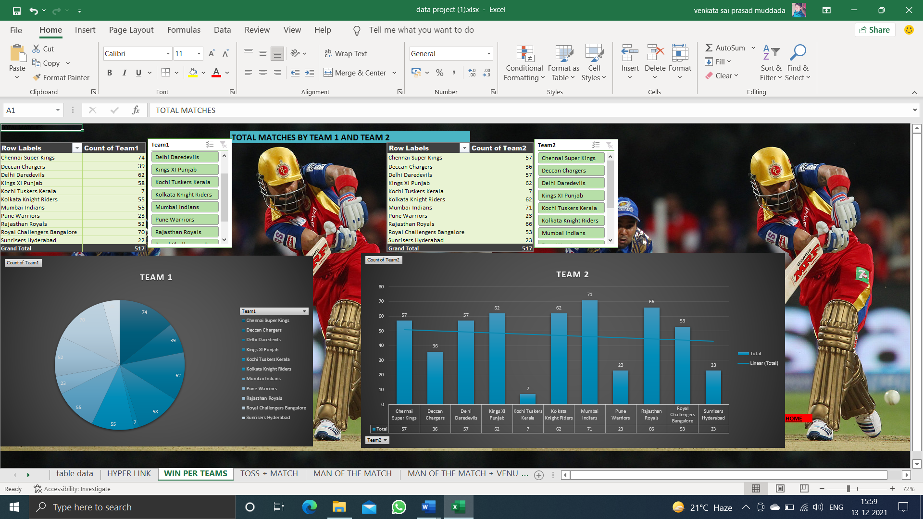

**Visualization:**

The results are then visualized in the form of the pie chart and bar-graph.

**2. Toss won by each team and toss+match:**

**Description:**

Total number of toss own by each team and taking the toss decision. As well as the team who won the toss are capable of winning the match by taking the toss decision.

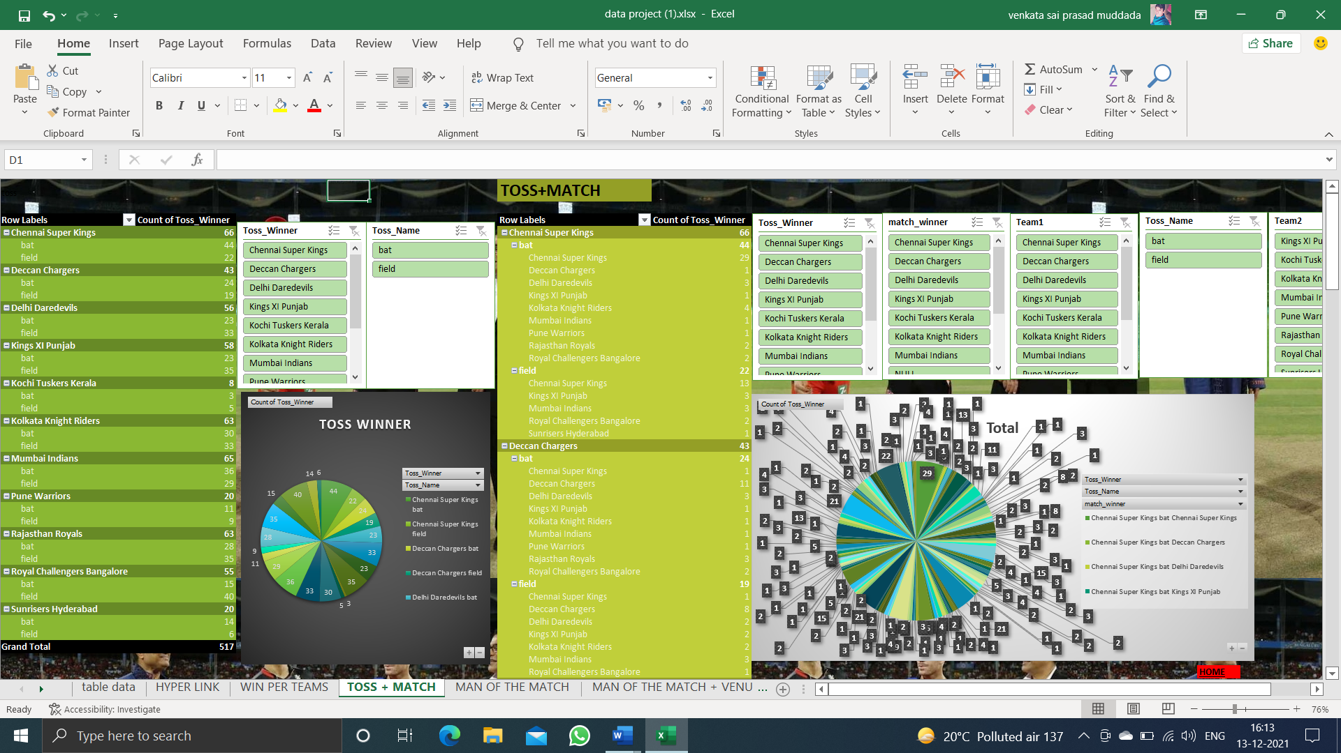**Results:**

**Visualization:**

We will use pie chart to visualize the data.





**3. Most Man of the match from the year 2008 to 2015:**

**Description:**

For this objective we are going to find out most man of the matches by each player from the year 2008 to 2015.

**Specific Requirements:**

The specific requirements is to create private table and count man of the matches.

**Visualization:**

The results are visualize with the help of doughnet and pie chart.

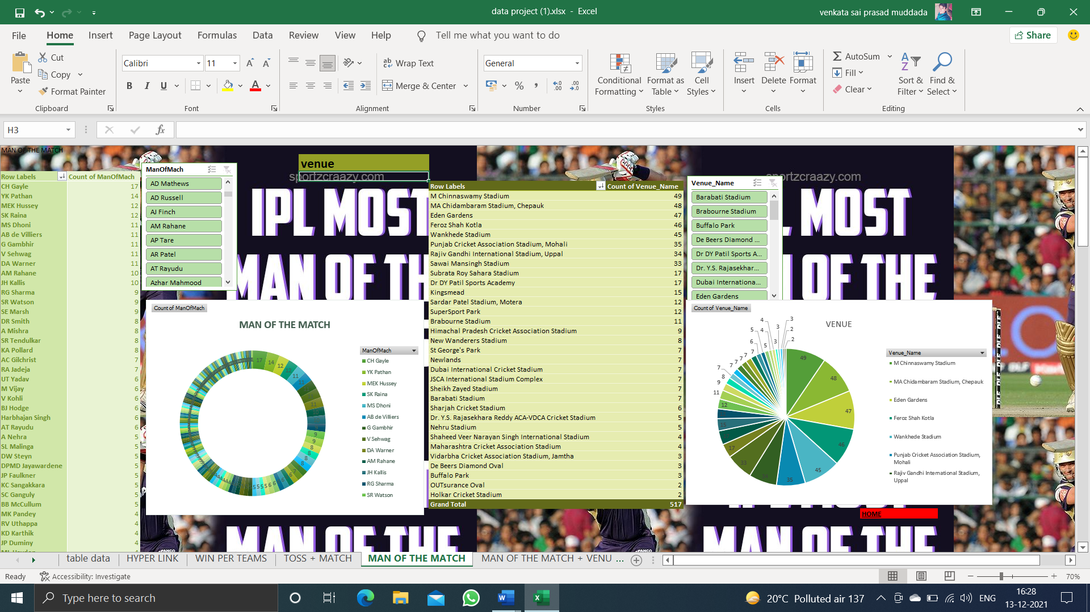

**4. Total number of man of the matches own by each player in specific venue:**

**Description:**

In this objective we are going to find out the most man of the matches own by each player in specific venue for the year 2008 to 2015.

**Specific requirements:**

We have to create a pivot table. No specific functions are used. We created a 3d pie chart for the data.

**Result:**

This the pivot table for the data.

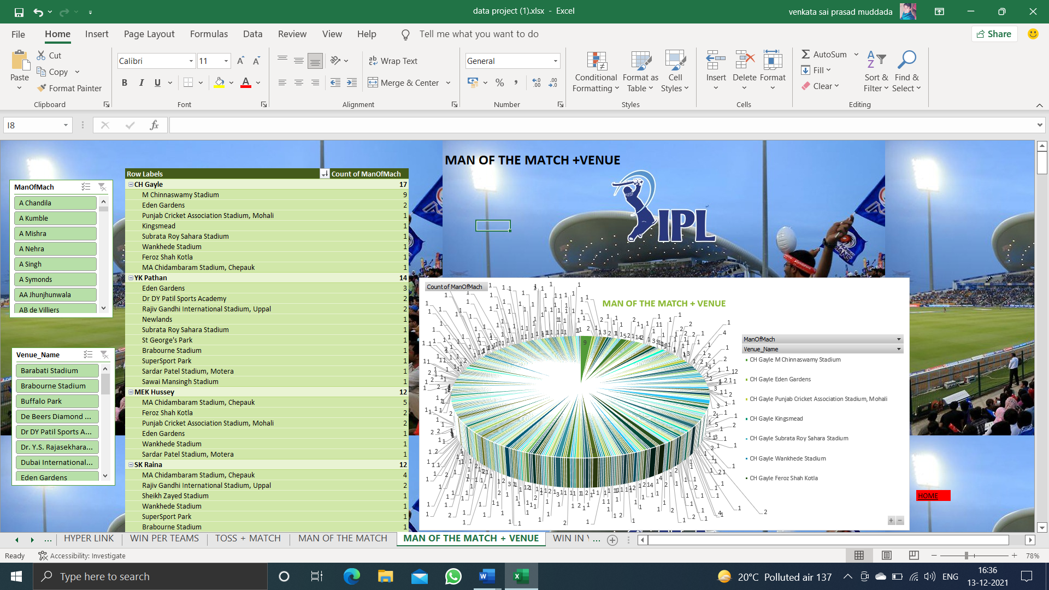

**Visualization:**

We visualize the above results with help of 3d pie chart.

**5. Wins per year:**

**Description:**

This objective we are going to find out total number of wins in each year by each team.

**Specific requirements:**

We have to create pivot table. No specific functions are used.

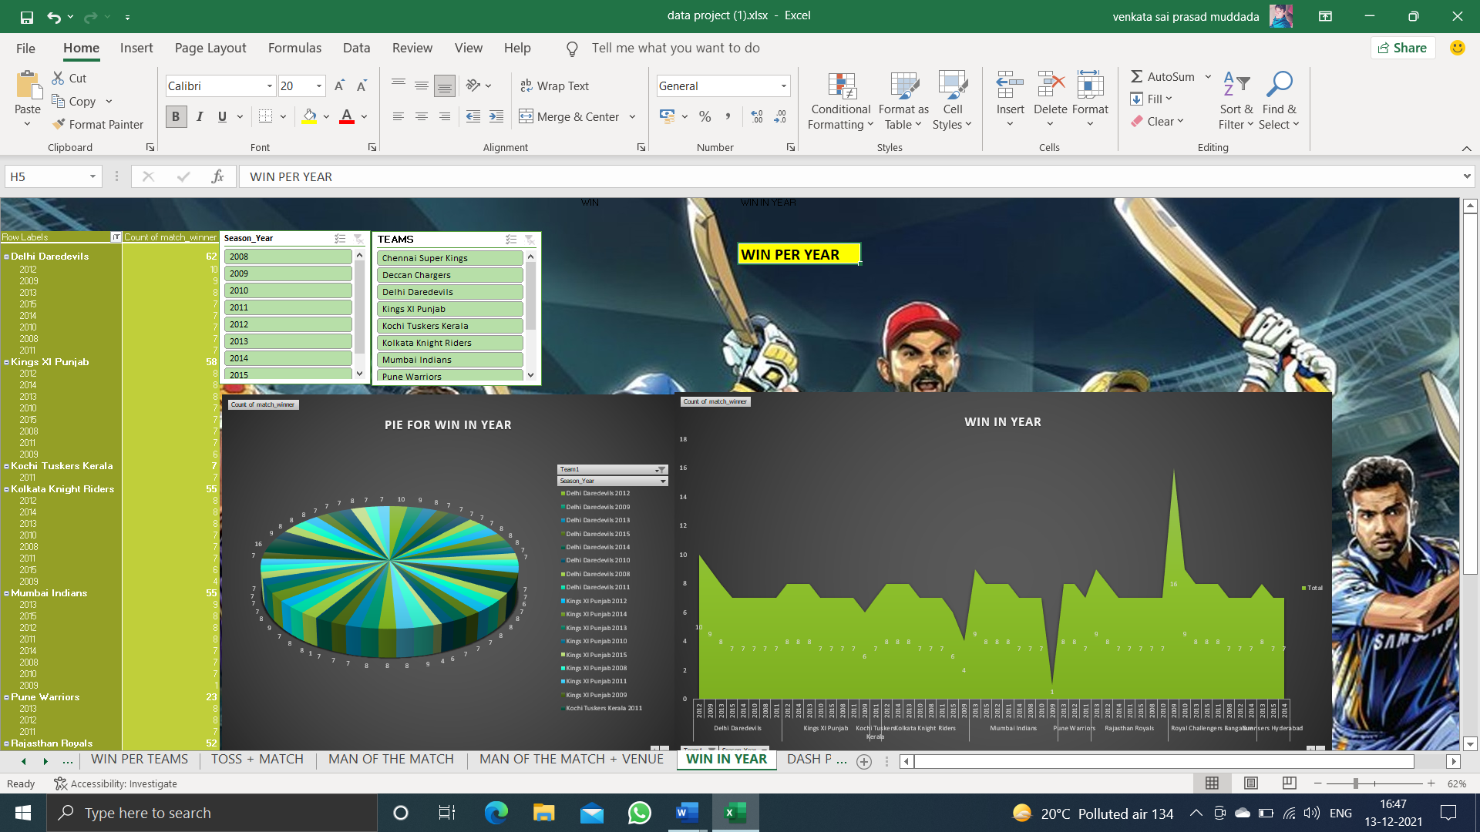**Results:**

Visualization:

The results are visualized in the form of 3d pie chart.

**Hyper linking:**

The HYPERLINK function creates a shortcut that jumps to another location in the current workbook, or opens a document stored on a network server, an intranet, or the Internet. When you click a cell that contains a HYPERLINK function, Excel jumps to the location listed, or opens the document you specified.

**Result:**

We have created a hyper linking in the home page for going specific objective in this worksheet.

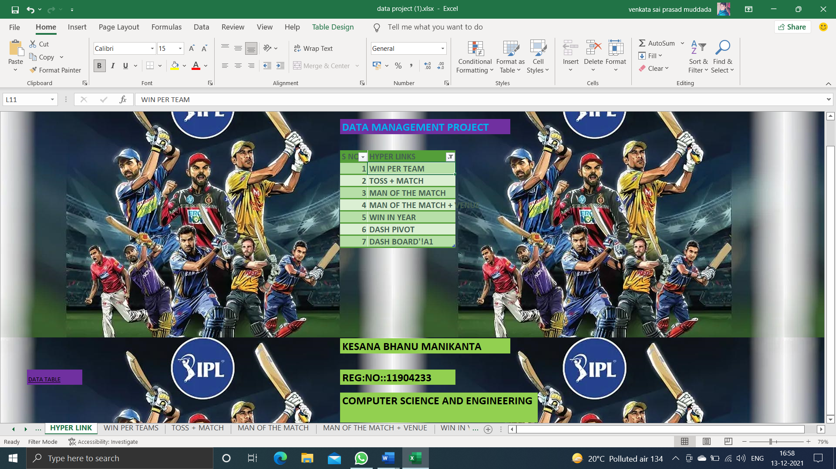

**ANALYSIS RESULTS**

**Most Won matches by the team:**

**Most toss winning team:**



**Top man of the matches player:**



**Top player venue:**



**Most man of the matches in venue by the player:**



**Most matches won by team in the years:**

**Complete pivot tables for final dashboard:**

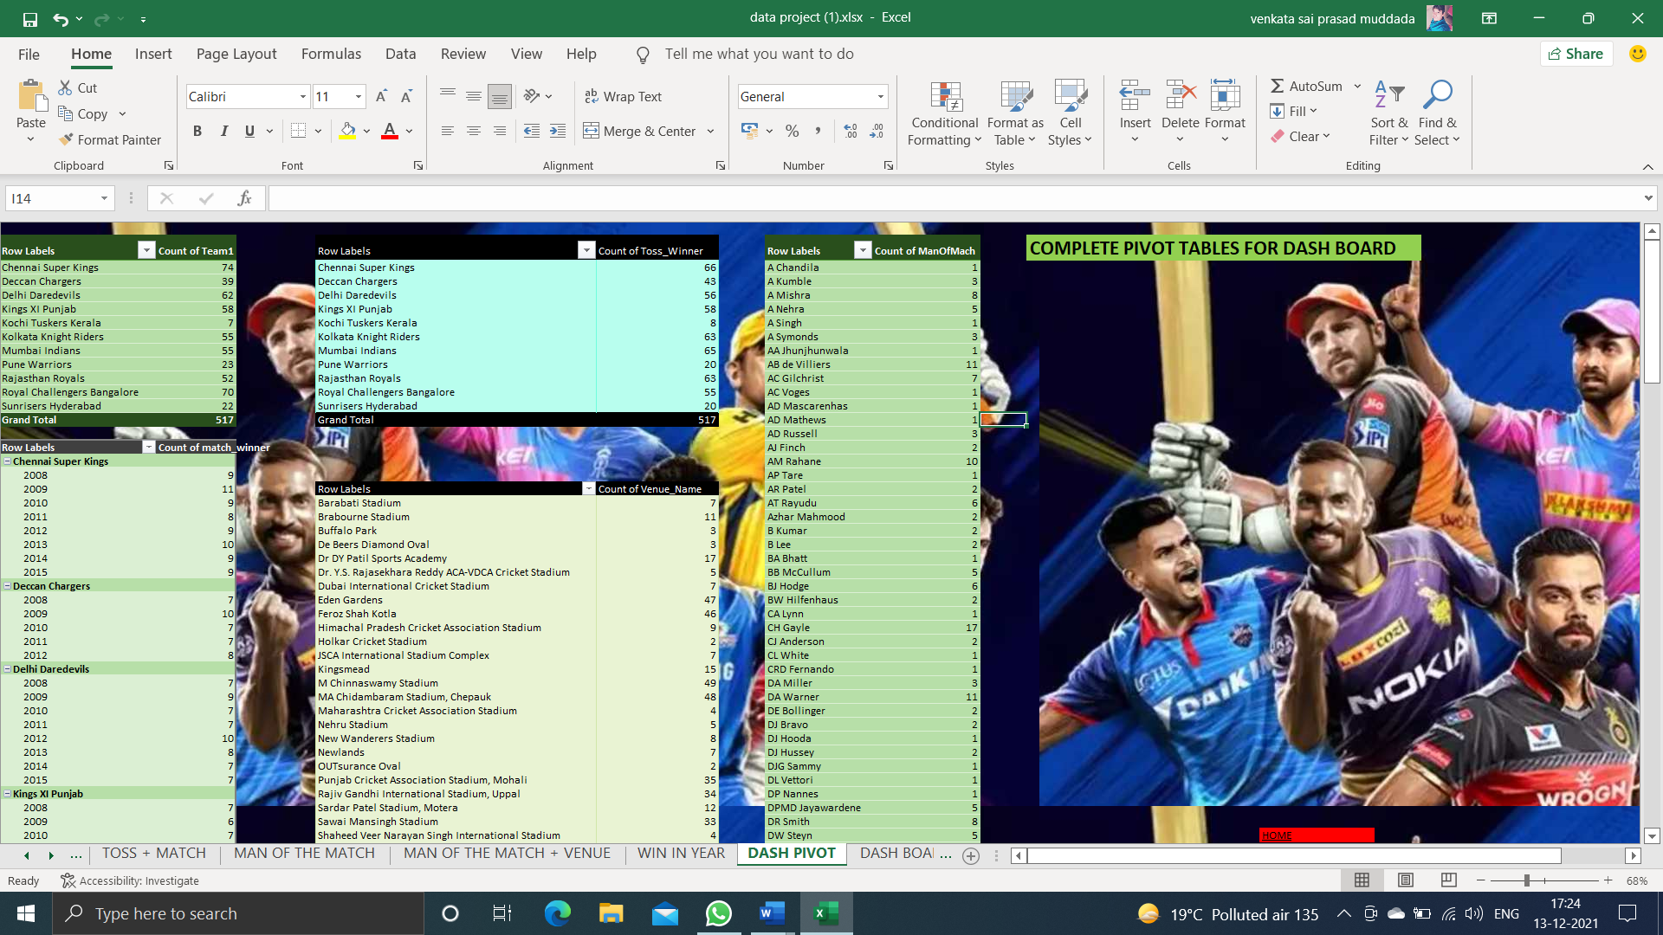

**Final Dashboard**

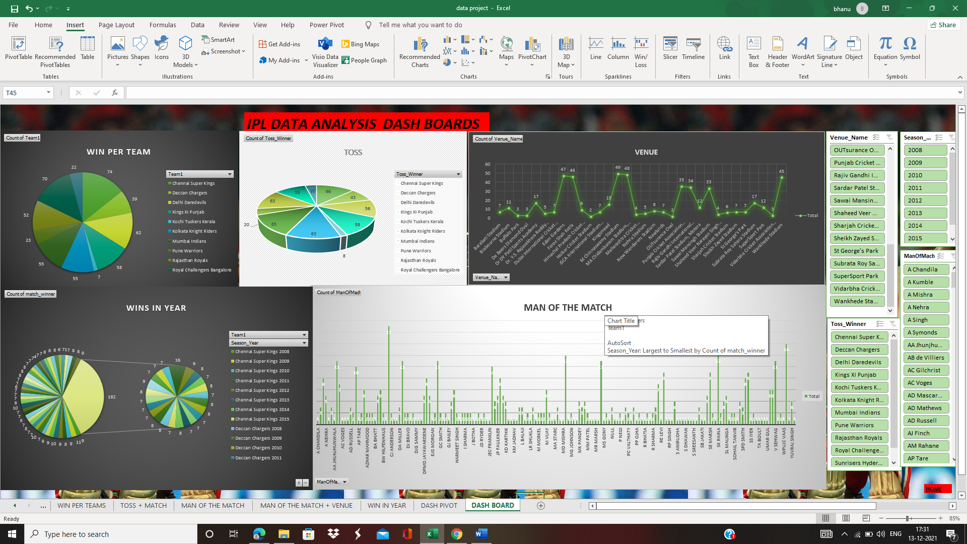

**Dashboard Will be giving all the brief details of the of work done on the project.**

# Future Scope

The Indian Premiere league is one of the best entertaining tournament of the world. Every Year of IPL come up with a new launching style.

IPL to me looks a very good option as far as providing the exposure to the young lot is concerned having played with the biggies of the games likes of Sachin, Kumble, Ponting etc. still hanging around with teams. As far as the skills is concerned, it does not dig deep into skill-testing especially for the batsmen, bowlers can still show their intelligence and skill by sticking to basics and containing the batter.

But with IPL the major issue is the crowd, since it takes place in major indian cities which are already hosts of test matches and some One-dayers it provides the crowd the option to choose between matches. So this decreases the attendance in the stadium during IPL since the crowd wants to see more or tough competitive cricket rather than friendly ventures.

And coming to the future, it has great scope and potential and with BCCI taking care of it so well it does not seem the trophy is gonna lose any shine in near future.

**Reference and Bibliography**

* Youtube
* Analytics Vidhya
* Kaggle
* Wikipedia.com
* Ipl.com
* Google.com